Deliverable 1
Laura – 21-Year-Old Teaching Student from Glasgow Scotland


Laura is a 21-year-old university student with aspirations to be a teacher. She lives in an apartment on the outskirts of Glasgow and gets up early to attend online lectures. She lives with her boyfriend (James) and one roommate (Jane). They rent a small apartment and it can be hard for Laura to concentrate on her course work, so she usually goes to her local library in order to study.
Sadly, with her hectic timetable Laura does not have a lot of free time. Since she started her online course, she no longer has the time to read books, which she likes to do for fun. However, she likes to keep her weekends free but there always seems to be an essay to write or assignments to complete. Therefore Laura can usually be found working away in the library on her laptop, occasionally checking her phone for emails or messages from her family.
Laura wants to have more free time for herself so she can de-stress and do more of the things that she used to enjoy. To achieve this, she has tried to find ways to better manage her time. She has asked her friends for help, but they didn’t seem to have the same problems she has. She needs the help of an expert but doesn’t know how to get make contact with the appropriate person.

More about Laura
Motivators for the Product: Laura has a large work load every week and she feels like she could possibly fail her course. This is because she has trouble managing the tasks and the amount of time she needs to spend on them.
Product Trigger Point: Laura asked her friends in the course about how they manage their time, but they didn’t have the same problem so they couldn’t help her. Instead, she went to her tutors, who directed her to Dr Smith an expert on time management.
Personal Computer: Heavily used, mainly for course work.
Internet Usage: Medium /Fluent; content, mainly uses social media and in-depth online searches for her course work
Smartphone: High / Fluent; checks emails and messages regularly. Uses phone to quickly search for information.
Social Networking: Facebook & twitter she likes to stay in touch with her close friends and family. She uses twitter to follow her favourite content creator.
Television Shows: The Witcher, Eastenders, Hell’s Kitchen, Sherlock, Magnum PI.
Magazines: Online newspaper subscription. Movies news

Narrative: Laura was directed to the web app when she spoke to her tutor about her problems around time management and her worries about not being able to finish the course. Her tutor informed her about the new university student help app. She advised her to carefully read the information about the doctors and their areas of expertise, so she could find exactly who would best suit her needs. Afterwards, Laura found the website and after reading the doctors information she selected the timetable for Dr Smith, the expert on time management. From there Laura could see when Dr Smith would be available. After she decided on a date and time for the appointment, she was then prompted to enter her student information and a brief description of the problems she was having. After submitting her information, she would get an email sent to her student account confirming the meeting. At the meeting, Laura explains her problems to Dr Smith. They go on to discuss techniques and strategies for managing time as well as ways of better focus on the task in hand. Laura soon noticed an improvement, when she started putting these techniques into practice and she immediately saw positive results. She could finish readings in two thirds of the time and also focus on a task and finish it in a single sitting. With these techniques, Laura now has time to relax on an evening and she can now finally get back to her favourite hobbies. With this extra relaxation time Laura has become less stressed and no longer worries about her studies. This in turn has led to her being happier overall and convinced her that she can manage her studies and pursue the career she desires.



Wireframes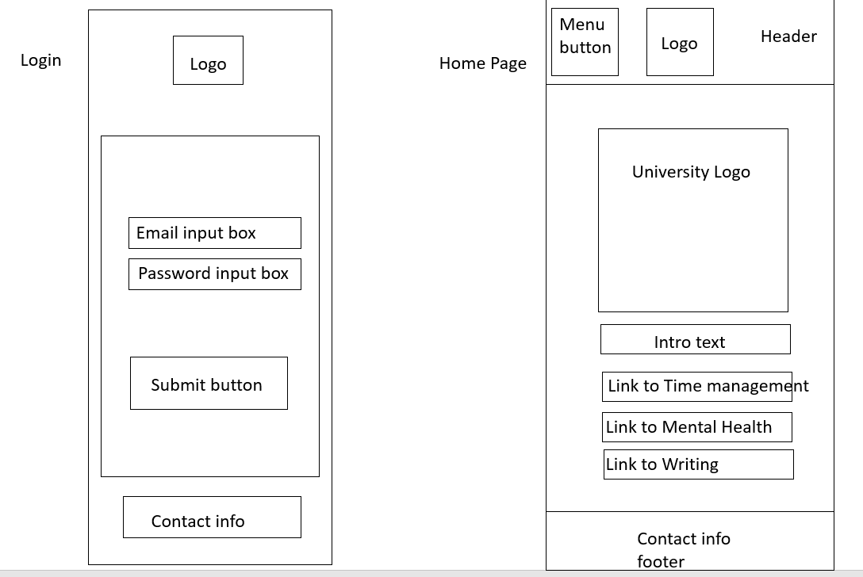
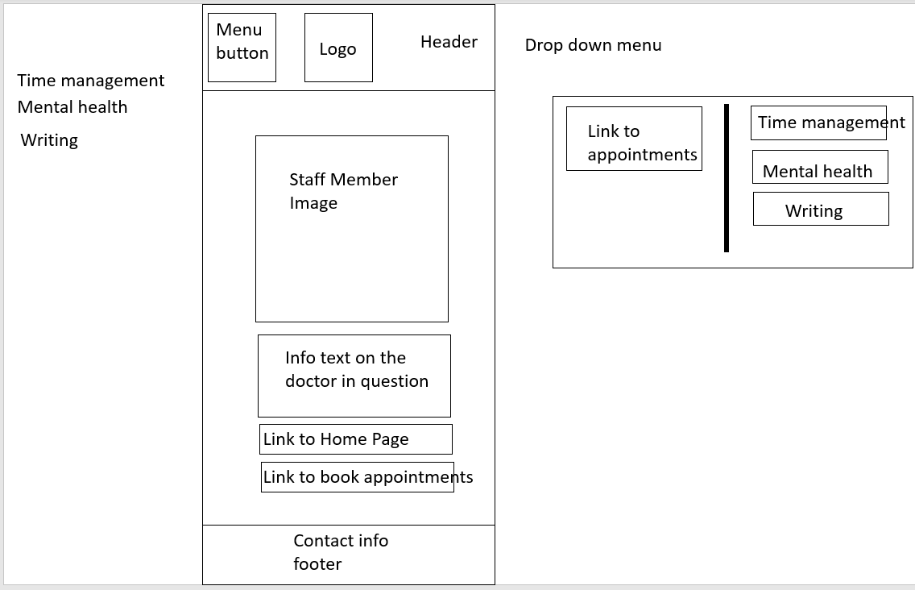
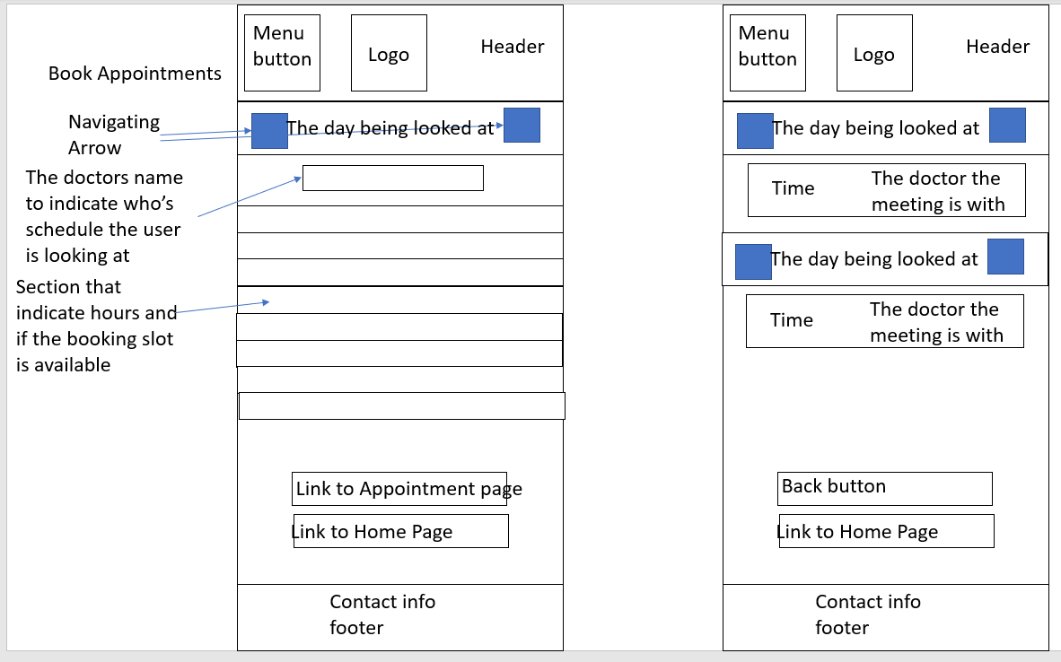
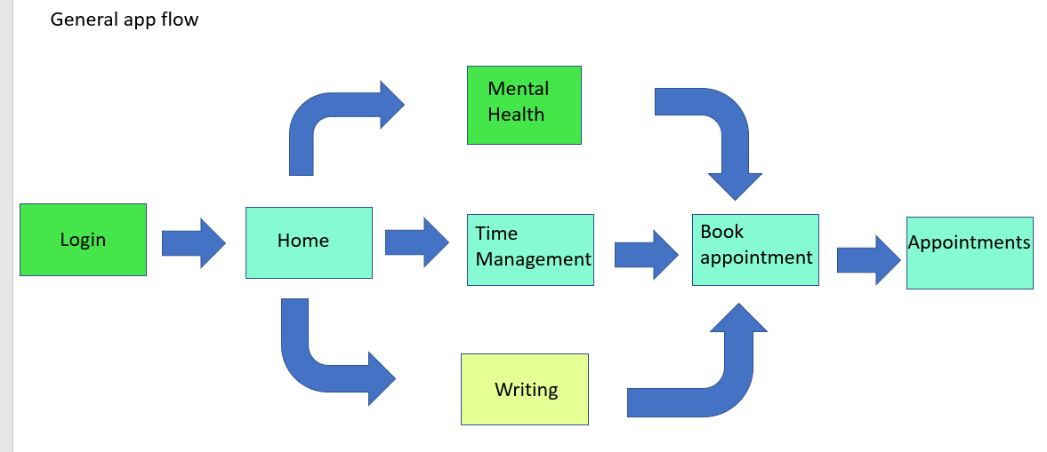

Figma design V1
https://www.figma.com/file/1UnDXe4gSRYXiKgyRKdeie/Untitled
Deliverable 2
Functional Requirements
- The app must provide information about the various services available that students can
book
- The app must provide information on staff
- Students must be able to book a day and time for any service using a calendar/time function
- Students should be able to change or delete appointment times
- The app must display when services can be booked and when they are not available
Requirements Evaluation V1
For the evaluation, I sat down with Participant A and gave him 10 minutes to explore my prototype design. I than asked him about the functional requirements. For requirement 1, Participant A stated that that requirement was met, and he was satisfied with the amount of information. This was not the case for requirement 2, which was met but Participant A advised that he wanted some more information. He stated that requirement 3 was fully met. For requirement 4 he said that it was partly met. He could cancel an appointment easily but was not able to change an appointment. Requirement 5 was met and was very clear to the user because the times where clearly displayed.
I then asked his if he had any problems with the design and if he had any suggestions about improving the app. Some of the small things that he noticed were that I did not need to use AM and PM with my appointments section as I was using a 24-hour system. He also mentioned that the navigation through the app could be made clearer. He pointed out that only the descriptions of the types of appointment gave the user any kind of idea of location. To solve this, I added a page title to each page. The main issue that Drew brought up was the fact that the app was unsupportive to returning users. The explanation he gave was that for a returning user to make a further appointment they would have to navigate through the same information as a new user instead of being able to just to the appointment booking page. In order to fix this, I added a button to the dropdown menu to take the user straight to the booking page. The original concept for the app was to preload the calendar depending on where the page was accessed and then load the corresponding doctor’s schedule. To fix the previous issue, I added the option to select the doctor whose schedule the user wants to see. I also added to the doctor’s descriptions to satisfy requirement 2. Lastly, I added a “change appointment” button to the appointments page that simulates changing the time by taking the user back to the booking page.
The SUS report Round 1
System Usability Scale (John Brooke: SUS – A quick and dirty usability scale).
(Have a look at the Using SUS section (page 5) in the document regarding instructions for filling in the survey. Since you may be doing this survey on your computer, double click on your selected score, then right click and select highlight text. Save the file with the highlighted scores and email it to one of your mates with whom you are swapping the file for scoring)

Participant A
Strongly Strongly disagree agree

1. I think that I would like to use this system 1 2 3 4 5 frequently

2. I found the system unnecessarily complex 1 2 3 4 5

3. I thought the system was easy to use 1 2 3 4 5

4. I think that I would need the support of a 1 2 3 4 5 technical person to be able to use this system

5. I found the various functions in this system 1 2 3 4 5 were well integrated

6. I thought there was too much inconsistency 1 2 3 4 5 in this system

7. I would imagine that most people would learn 1 2 3 4 5 to use this system very quickly

8. I found the system very cumbersome to use 1 2 3 4 5

9. I felt very confident using the system 1 2 3 4 5

10. I needed to learn a lot of things before 1 2 3 4 5
I could get going with this system
The raw data is as shown above and the converted score is 3,1,3,4,4,4,4,3,3,4
Thus, the total score calculation is 3 + 1 + 3 + 4 + 4 + 4 + 4 + 3 + 3 + 4 = 33 33 x 2.5 = 82.5
A score of 82.5 shows that the design is well above average in teams of usability. With the average being 68 If the design was given a rough grade, it would be A with A being 90-80, B 80-70, C 70-60, D 60-50, F 50-40.
Participant B
Strongly Strongly disagree agree

1. I think that I would like to use this system 1 2 3 4 5 frequently

2. I found the system unnecessarily complex 1 2 3 4 5

3. I thought the system was easy to use 1 2 3 4 5

4. I think that I would need the support of a 1 2 3 4 5 technical person to be able to use this system

5. I found the various functions in this system 1 2 3 4 5
were well integrated

6. I thought there was too much inconsistency 1 2 3 4 5 in this system

7. I would imagine that most people would learn 1 2 3 4 5 to use this system very quickly

8. I found the system very cumbersome to use 1 2 3 4 5

9. I felt very confident using the system 1 2 3 4 5

10. I needed to learn a lot of things before 1 2 3 4 5 I could get going with this system
The raw data is as shown above and the converted score is 2,3,3,4,2,3,4,3,3,4
Thus, the total score calculation is 2 + 3 + 3 + 4 + 2 + 3 + 4 + 3 + 3 + 4 = 31 x 2.5 = 77.5
A score of 77.5 shows that the design is above average in teams of usability. With the average being 68 If the design was given a rough grade, it would be B with A being 90-80, B 80-70, C 70-60, D 60-50, F 50-40.
Participant C
Strongly Strongly disagree agree

1. I think that I would like to use this system 1 2 3 4 5 frequently

2. I found the system unnecessarily complex 1 2 3 4 5

3. I thought the system was easy to use 1 2 3 4 5

4. I think that I would need the support of a 1 2 3 4 5 technical person to be able to use this system

5. I found the various functions in this system 1 2 3 4 5 were well integrated

6. I thought there was too much inconsistency 1 2 3 4 5 in this system

7. I would imagine that most people would learn 1 2 3 4 5 to use this system very quickly

8. I found the system very cumbersome to use 1 2 3 4 5

9. I felt very confident using the system 1 2 3 4 5

10. I needed to learn a lot of things before 1 2 3 4 5 I could get going with this system
The raw data is as shown above and the converted score is 3,1,3,3,4,2,4,2,3,4
Thus, the total score calculation is 3 + 1 + 3 + 3 + 4 + 2 + 4 + 2 + 3 + 4 = 29 x 2.5 = 72.5
A score of 72.5 shows that the design is above average in teams of usability. With the average being 68 If the design was given a rough grade, it would be B with A being 90-80, B 80-70, C 70-60, D 60-50, F 50-40.
When getting the average of these surveys the result is 77.5. This means that over all the design is rather well received.
Figma design V2
https://www.figma.com/file/qjbNDUGIqBry4dGak0JYvt/CMP206-app-design-V2?node-id=0%3A1
Deliverable 3
Functional Requirements
- The app must provide information about the various services available that students can
book
- The app must provide information on staff
- Students must be able to book a day and time for any service using a calendar/time function
- Students should be able to change or delete appointment times
- The app must display when services can be booked and when they are not available
Requirements Evaluation V2
For the second evaluation I sat down with Participant A again as he had experience with the previous design and was familiar with the functional requirements. Functional requirements 1, 3 and 5 were met with the first design. Requirement 2 was met but Participant A suggested I give more detail to the descriptions of the Doctors running the sessions. This was easily fixed by adding a few more sentences. Requirement 4 was half met by the first design since the user could delete an appointment but not change an appointment. To rectify this, I added a button to the appointments page so that the user could select this and be taken to the book appointment page.
With the functional requirement met I decided to make some changes to the design flow and to add an accessibility options section to meet the non-functional requirements. While discussing the evaluation for the first design it was pointed out that the design was not friendly to a returning user. The original design worked on the basis that the appointment page would be entered by one of the information pages. This would then be used to populate the calendar with the respective doctor’s timetable. This process was to long for a returning user, so I added a navigation option to the main dropdown menu to take the user straight to the booking page. I then added a sup menu with each doctor’s name and the timetable would be populated that way making it a much faster operation for returning users. The accessibility options I added could in a practical version change the font size and change the colour scheme depending on the user’s potential sight requirements.
Survey round 2 comparison and interpretation
The second round of surveys can be found below. As before three surveys were given out one to a fellow student and the others were given to two non-computing students to get an example of the average potential user of the app. This round of surveys uses the same SUS survey as the first set. The average of the collated surveys is 90.8. This places the design with an A grade on the hypothetical scale. The last average score was 77.5. Therefore, a B grade. This shows a clear improvement in the second design over the first. I believe that this improvement is due to the added improvements to the overall app flow and small tweaks to repeatedly used systems, so they are streamlined.

Future improvements
Some potential improvements to the design could be:
- Changing the font to be more user friendly. A” thick sans” font is welcoming and works well for people with sight issues.
- An emergency booking page could also be added. so users who desperately need an appointment can get one as soon as posable.

SUS Results Round 2
Participant A
Strongly Strongly disagree agree

1. I think that I would like to use this system 1 2 3 4 5 frequently

2. I found the system unnecessarily complex 1 2 3 4 5

3. I thought the system was easy to use 1 2 3 4 5

4. I think that I would need the support of a 1 2 3 4 5 technical person to be able to use this system

5. I found the various functions in this system 1 2 3 4 5 were well integrated

6. I thought there was too much inconsistency 1 2 3 4 5 in this system

7. I would imagine that most people would learn 1 2 3 4 5 to use this system very quickly

8. I found the system very cumbersome to use 1 2 3 4 5

9. I felt very confident using the system 1 2 3 4 5

10. I needed to learn a lot of things before 1 2 3 4 5
I could get going with this system

The raw data is as shown above and the converted score is 3,4,4,4,4,4,3,3,3,4
Thus, the total score calculation is 3 + 4 + 4 + 4 + 4 + 4 + 3 + 3 + 3 + 4 = 36 36 x 2.5 = 90
A score of 72.5 shows that the design is above average in teams of usability. With the average being 68 If the design was given a rough grade, it would be A with A being 90-80, B 80-70, C 70-60, D 60-50, F 50-40.

Participant B
Strongly Strongly disagree agree

1. I think that I would like to use this system 1 2 3 4 5 frequently

2. I found the system unnecessarily complex 1 2 3 4 5

3. I thought the system was easy to use 1 2 3 4 5

4. I think that I would need the support of a 1 2 3 4 5 technical person to be able to use this system

5. I found the various functions in this system 1 2 3 4 5 were well integrated

6. I thought there was too much inconsistency 1 2 3 4 5 in this system

7. I would imagine that most people would learn 1 2 3 4 5 to use this system very quickly

8. I found the system very cumbersome to use 1 2 3 4 5

9. I felt very confident using the system 1 2 3 4 5

10. I needed to learn a lot of things before 1 2 3 4 5
I could get going with this system

The raw data is as shown above and the converted score is 2,4,4,4,3,4,4,2,4,4
Thus, the total score calculation is 2 + 4 + 4 + 4 + 3 + 4 + 4 + 2 + 4 + 4 = 35 35 x 2.5 = 87.5
A score of 72.5 shows that the design is above average in teams of usability. With the average being 68 If the design was given a rough grade, it would be A with A being 90-80, B 80-70, C 70-60, D 60-50, F 50-40.

Participant C
Strongly Strongly disagree agree

1. I think that I would like to use this system 1 2 3 4 5 3 frequently

2. I found the system unnecessarily complex 1 2 3 4 5 4

3. I thought the system was easy to use 1 2 3 4 5 4

4. I think that I would need the support of a 1 2 3 4 5 4 technical person to be able to use this system

5. I found the various functions in this system 1 2 3 4 5 3 were well integrated

6. I thought there was too much inconsistency 1 2 3 4 5 4 in this system

7. I would imagine that most people would learn 1 2 3 4 5 4 to use this system very quickly

8. I found the system very cumbersome to use 1 2 3 4 5 4

9. I felt very confident using the system 1 2 3 4 5 4

10. I needed to learn a lot of things before 1 2 3 4 5 4
I could get going with this system

The raw data is as shown above and the converted score is 3,4,4,4,3,4,4,4,4,4
Thus, the total score calculation is 3 + 4 + 4 + 4 + 3 + 4 + 4 + 4 + 4 + 4 = 38 38 x 2.5 = 95
A score of 72.5 shows that the design is above average in teams of usability. With the average being 68 If the design was given a rough grade, it would be A+ with A being 90-80, B 80-70, C 70-60, D 60-50, F 50-40.
When getting the average of these surveys the result is 90.8. This means that over all that the design is very well received.

